**IONIC APP ON ANDROID DEVICE**

**REF:**

<http://ionicframework.com/docs/intro/deploying/>

<https://cordova.apache.org/docs/en/latest/guide/platforms/android/>

<http://spring.io/guides/gs/android/>

<https://stackoverflow.com/questions/35534635/windows-cordova-build-error-failed-to-find-android-home-environment-variable>

<https://github.com/ionic-team/ionic/issues/11591>

<https://gradle.org/install/>

IN ORDER TO ACHIEVE THIS WE HAVE TO INSTALL ANDROID STUDIO FIRST:

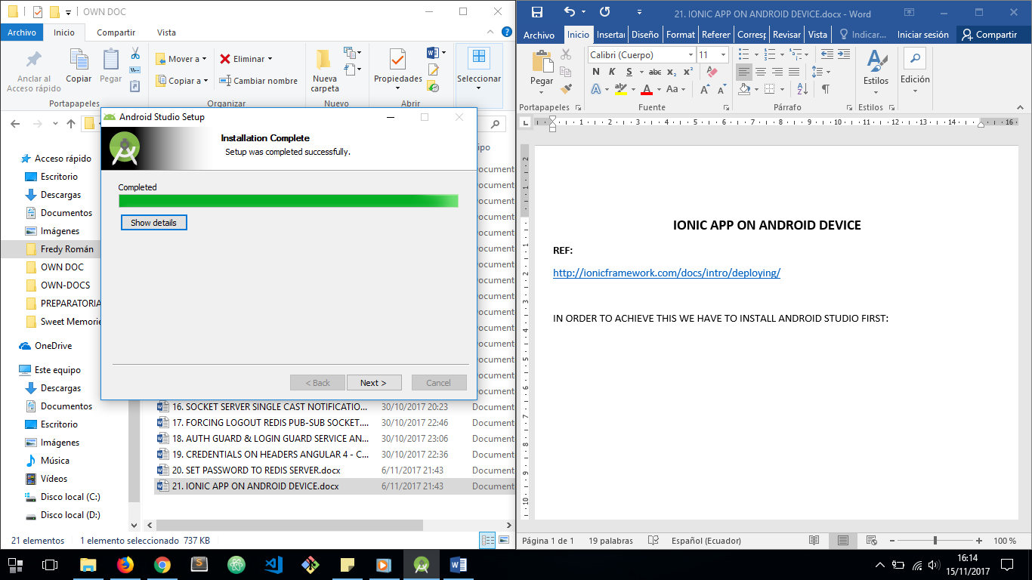

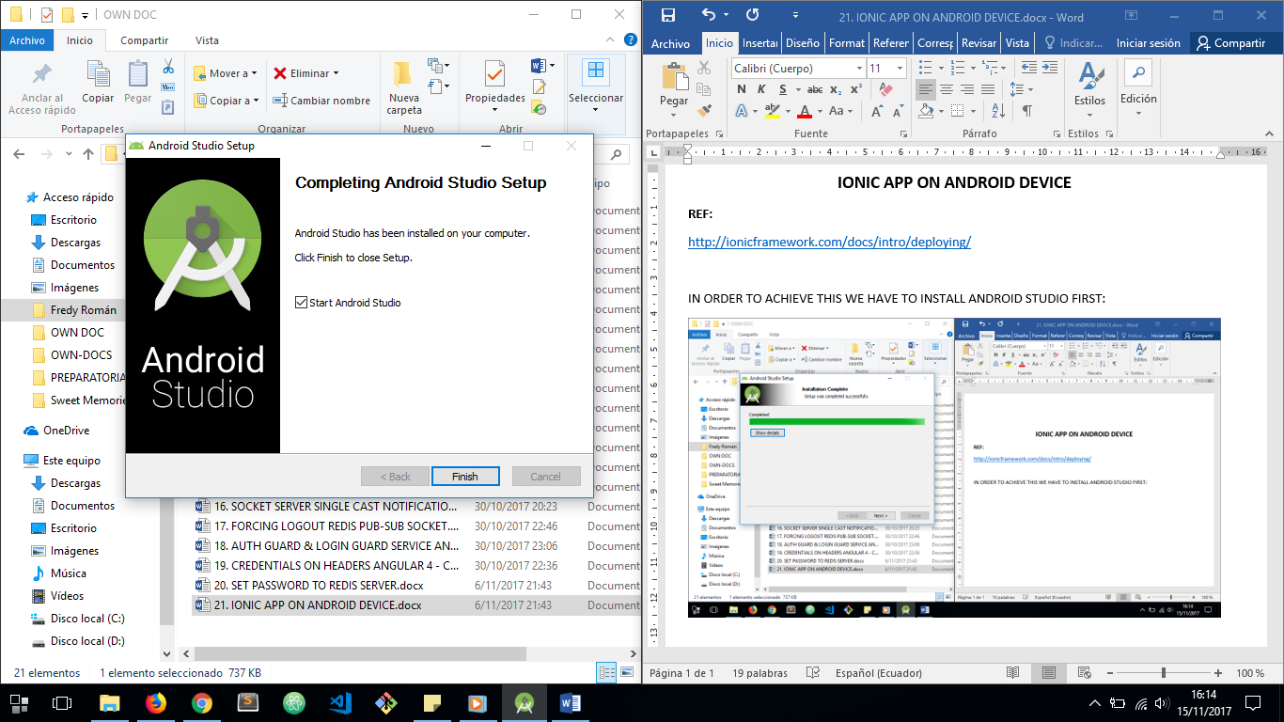

THEN WE HAVE TO CHANGE SDK FOLDER PATH TO BE INSTALLED:

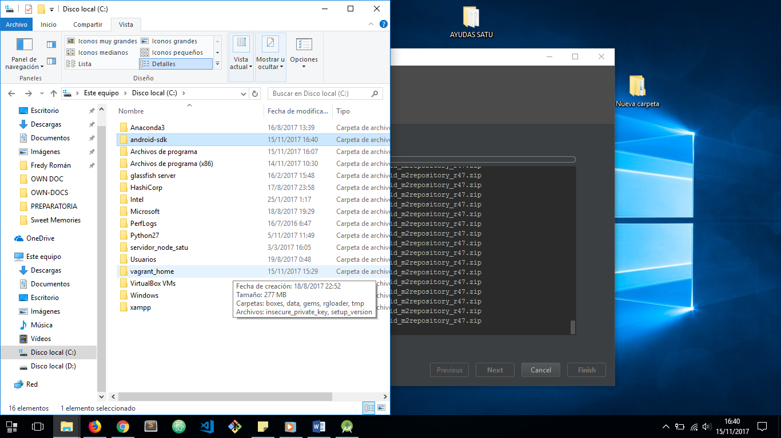

THEN WE HAVE TO ALLOW DOWNLOADING OF TOOLS:

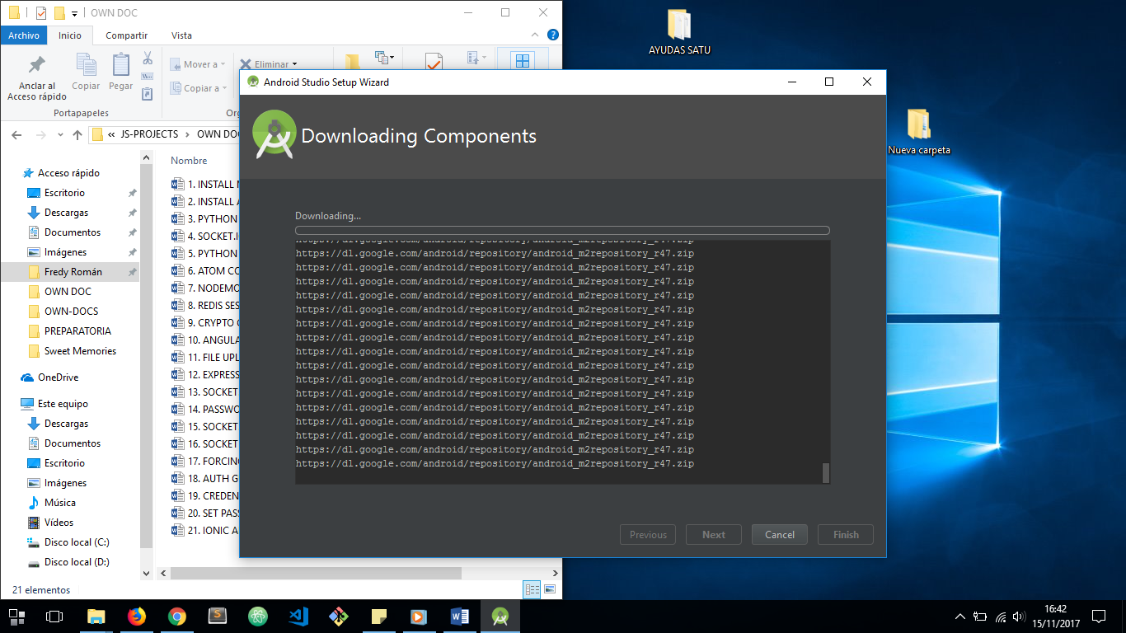

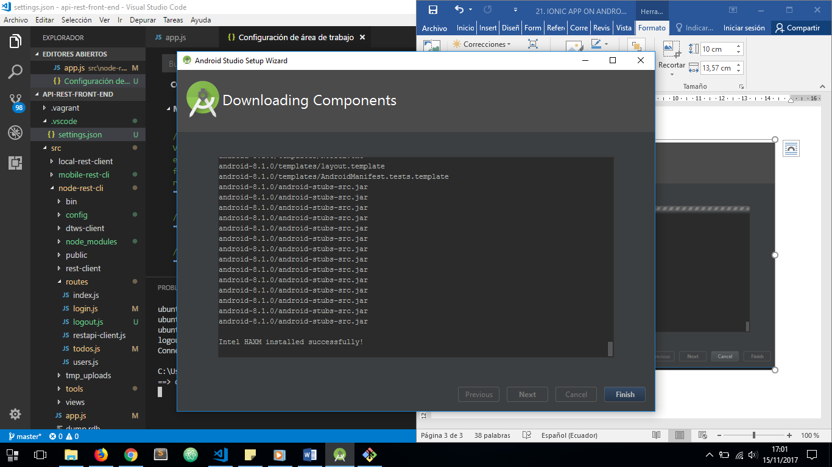

ONCE INSTALLED ANDROID STUDIO WE HAVE OPEN SDK MANAGER:

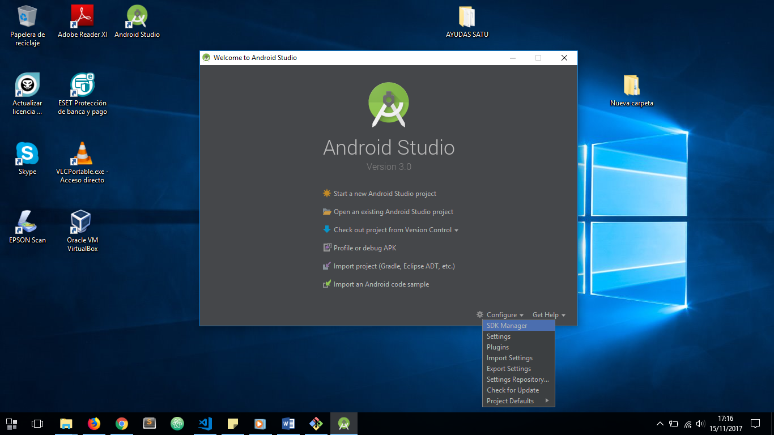

WE HAVE TO BE SURE WE HAS ALREADY INSTALLED NEXT IN OUR SDK MANAGER:

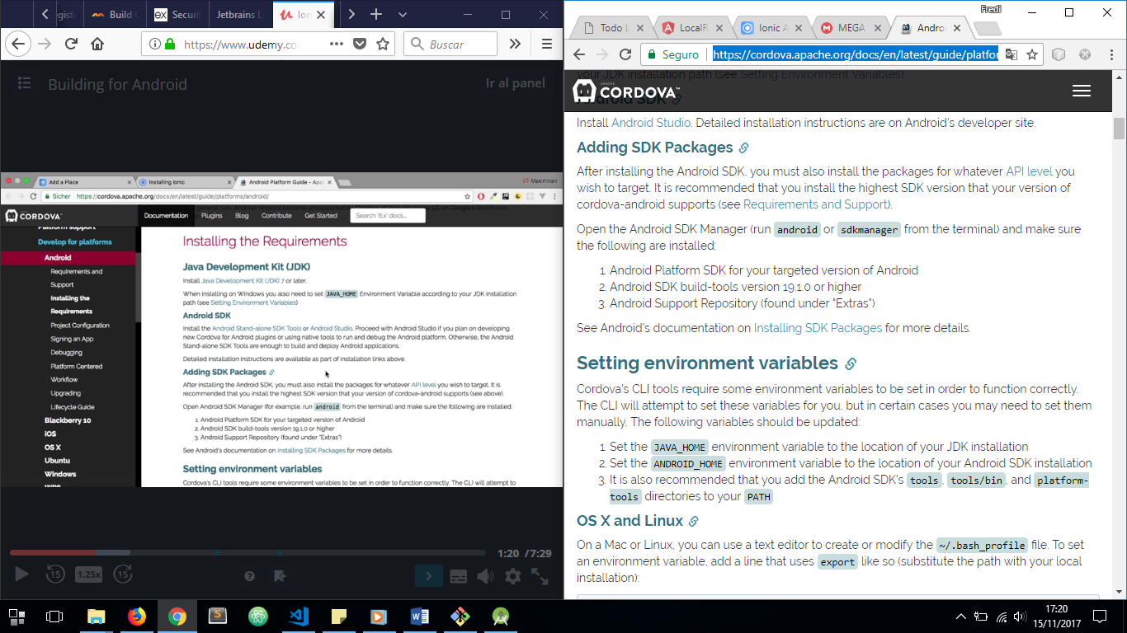

CHECK THAT REQUIREMENTS:

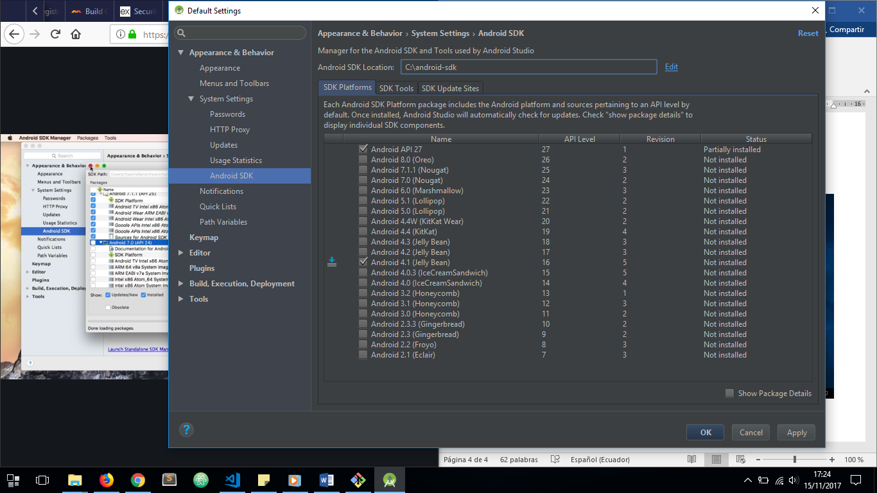

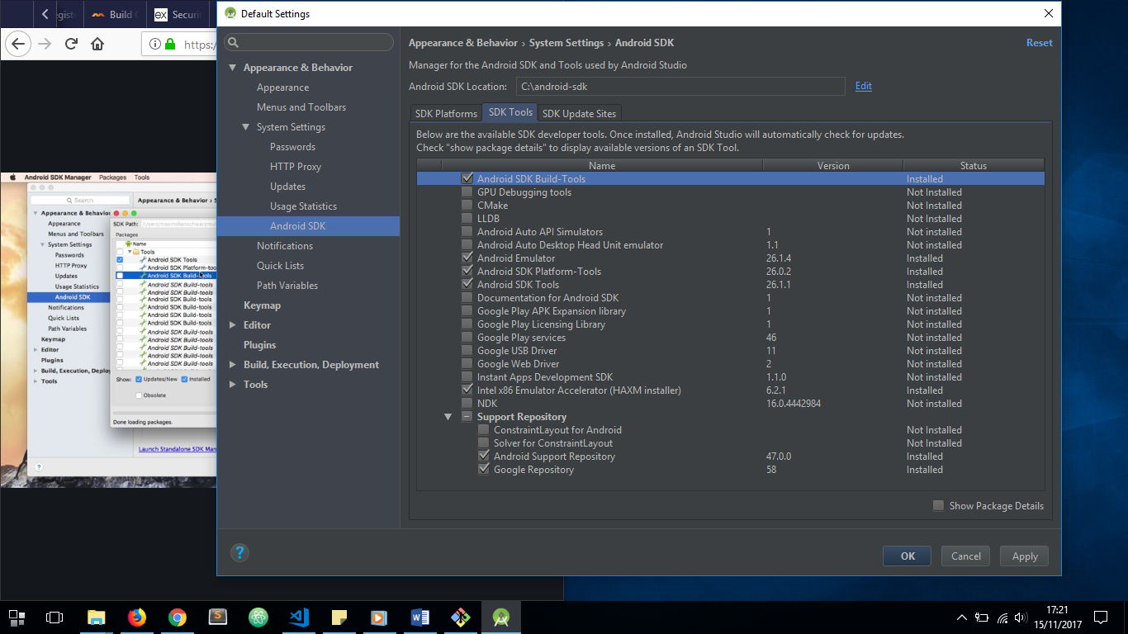

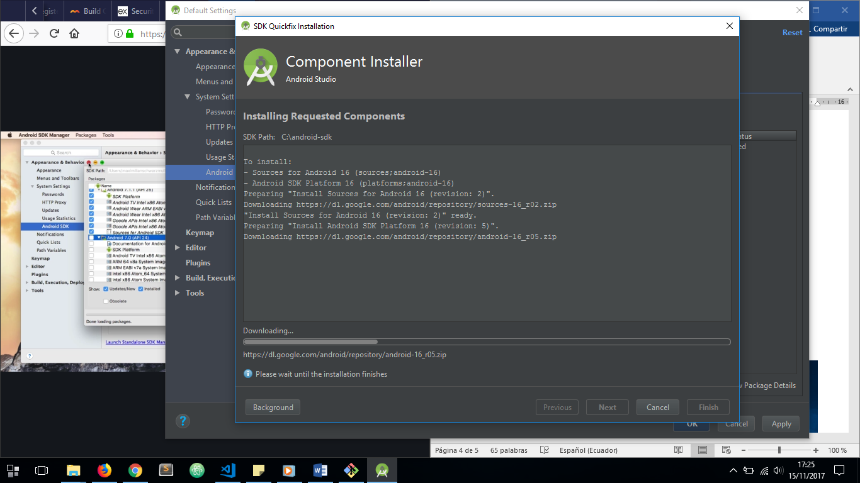

NOW WE ARE READY TO RUN OUR APP ON AN ANDROID DEVICE.

FIRST WE HAVE TO ADD A NEW ANDROID PLATFORM THROUGH THE COMAND LINE LOCATED IN OUR IONIC 3 PROJECT:

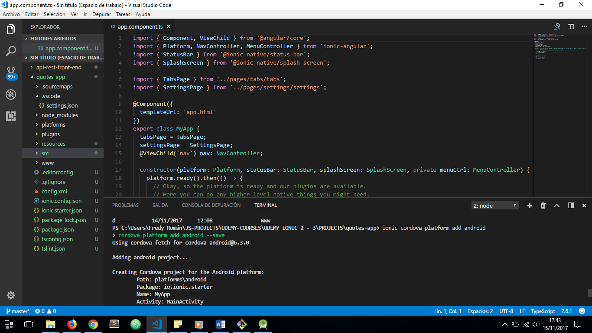

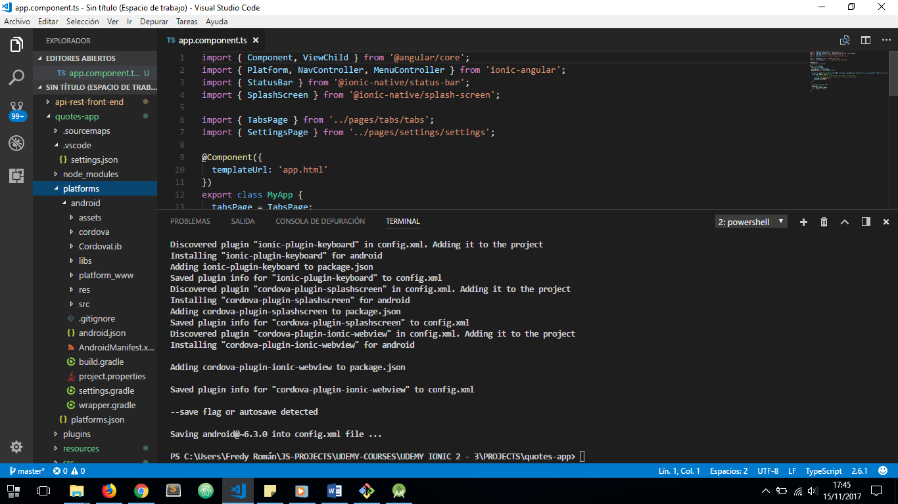

AND NOW THE PLATFORM IS INSTALLED:



NOW IT’S TIME TO BUILD OUR APP TO BE DEPLOYED WITH ANDROID SDK:

RUN ***ionic build android*** OR ***ionic cordova build android***:

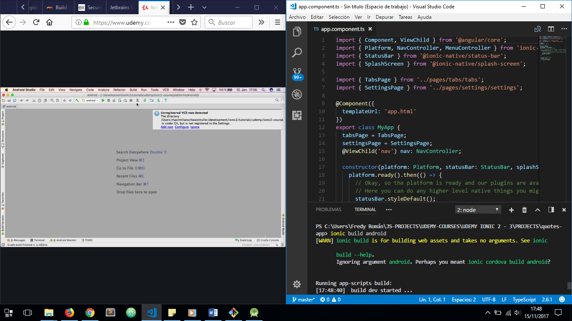

IF WE GOT NEXT ERROR, WE HAVE TO SPECIFY ***ANDROID_HOME***ENVIRONMENT VARIABLE AND CONFIGURE ***PATH*** TO SUPPORT ANDROID SDK TOOLS AND PLATFORM TOOLS:

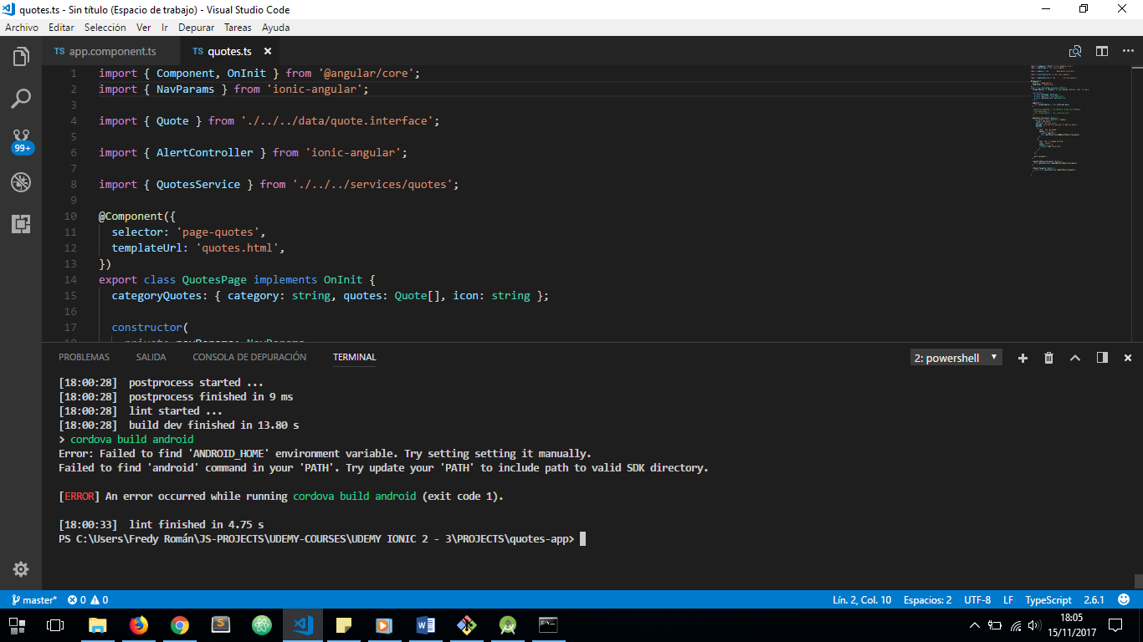

1. ***ANDROID_HOME*** VARIABLE:

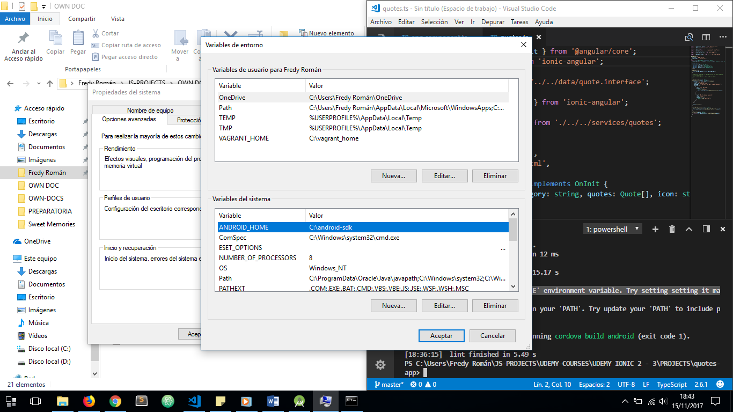

1. ***PATH*** VARIABLE, ADDING NEXT ARGUMENTS:

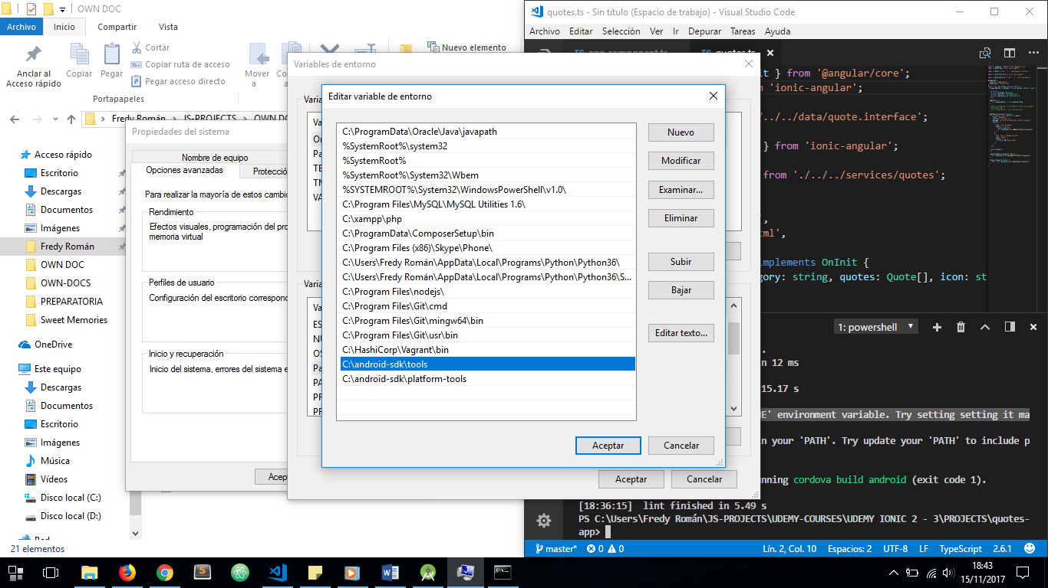

IN ORDER TO TAKE EFFECT OF NEW ENVIRONMENT VARIABLES CHANGES, WE MUST RESTART OUR WINDOWS SYSTEM.

**NOTICE:** WHEN USING CORDOVA VERSION 7.0 AND WITH ANDROID SDK TOOLS 26 WE HAVE TO INSTALL ***GRADLE*** TOOL MANUALLY, THIS IS TOOL WHICH WILL ALLOW US TO RUN OUR IONIC APPS ON AN ANDROID DEVICE. **REF:** <https://github.com/ionic-team/ionic/issues/11591>

SO NOW WE HAVE TO FOLLOW NEXT STEPS TO INSTALL GRADLE MANUALLY (I HAVE FOLLOW NEXT LINK STEPS <https://gradle.org/install/> IN INSTALL MANUALLY SECTION):

1. INSTALL GRADLE DISTRIBUTION (I’VE CHOSEN AN STABLE VERSION) GO TO THIS LINK <https://gradle.org/releases/>:

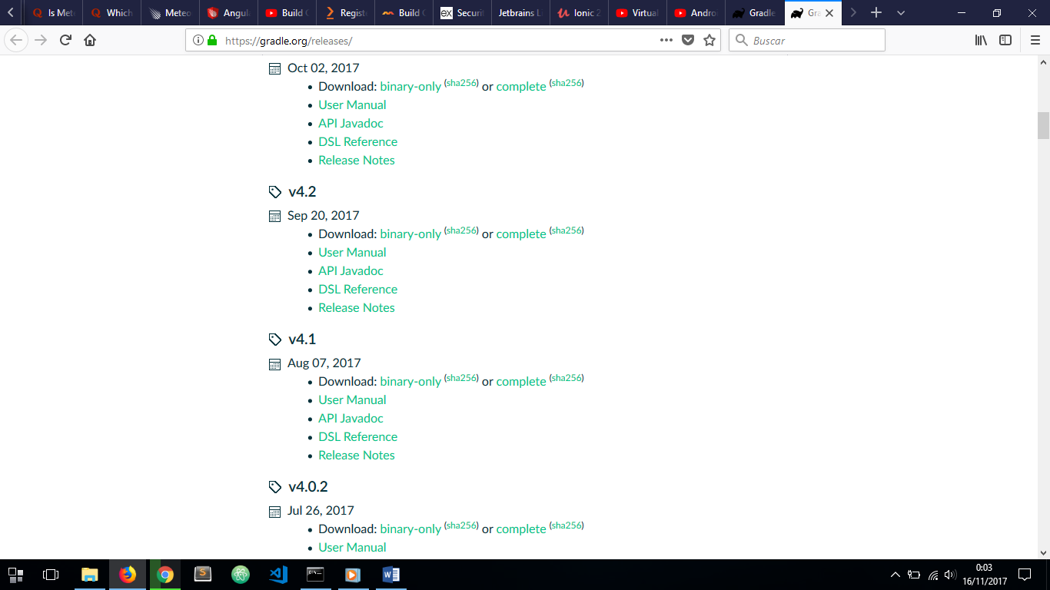

1. CREATE A NEW FOLDER WHEREVER YOU WANT TO SPECIFY GRADLE PACKAGE DOWNLOADED. THEN UNZIP GRADLE FILES THERE:

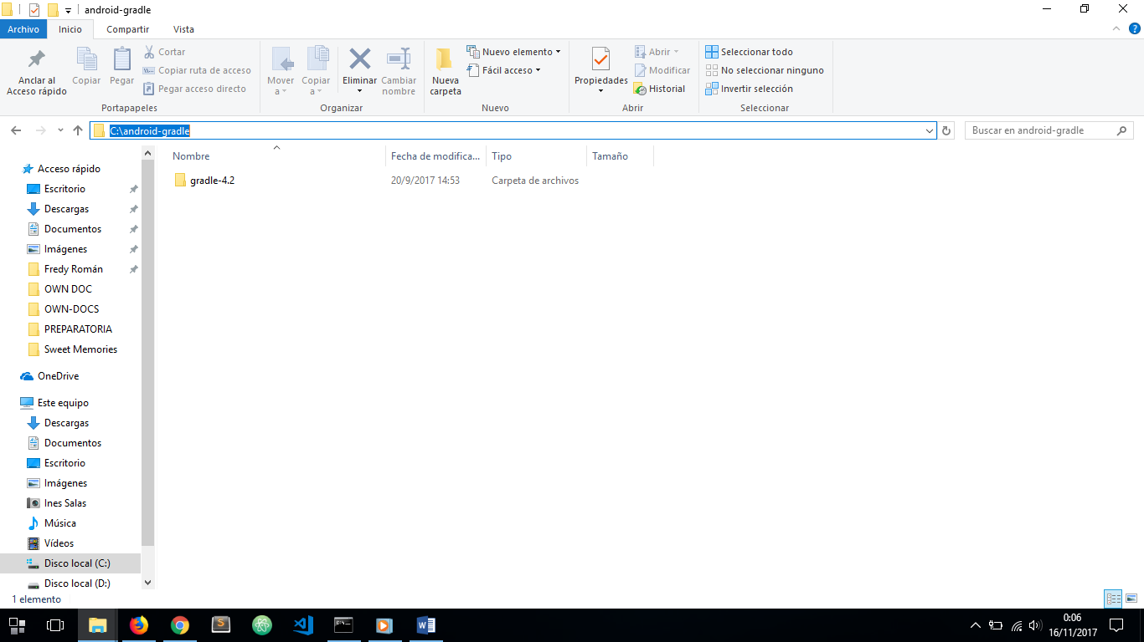

1. NOW WE HAVE TO ADD TO ***PATH*** ENVIRONMENT VARIABLE OF WINDOWS SYSTEM NEXT PATH: ***C:\android-gradle\gradle-4.2\bin***

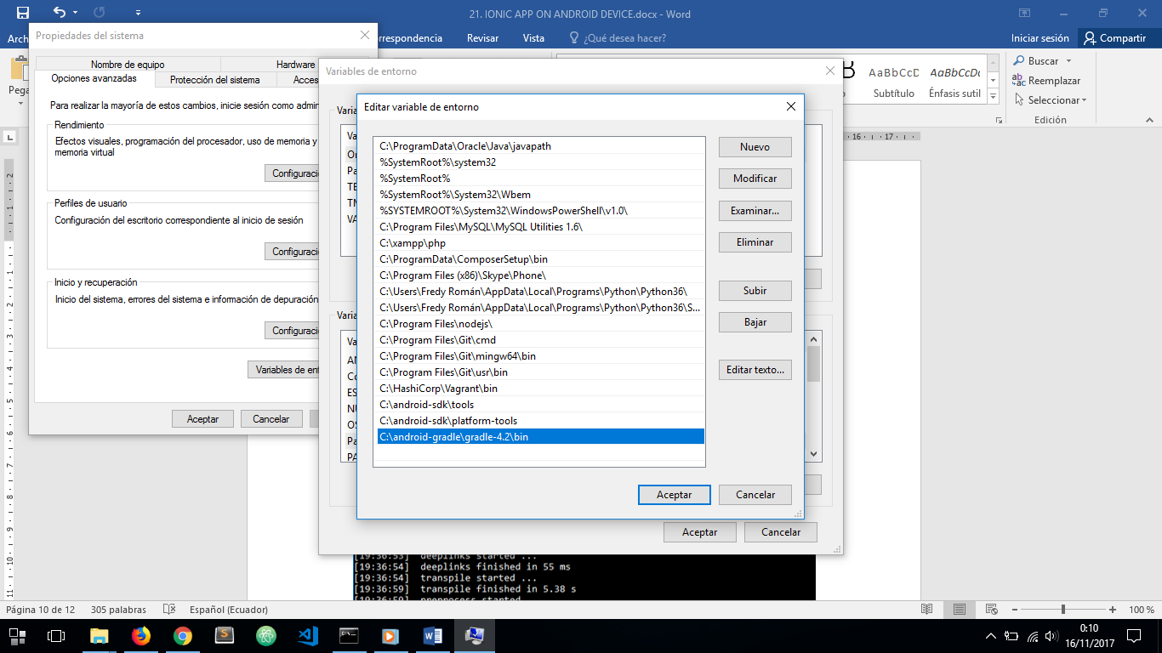

1. RESTART SYSTEM, AND THEN RUN ***gradle –v*** ON COMMAND PROMPT

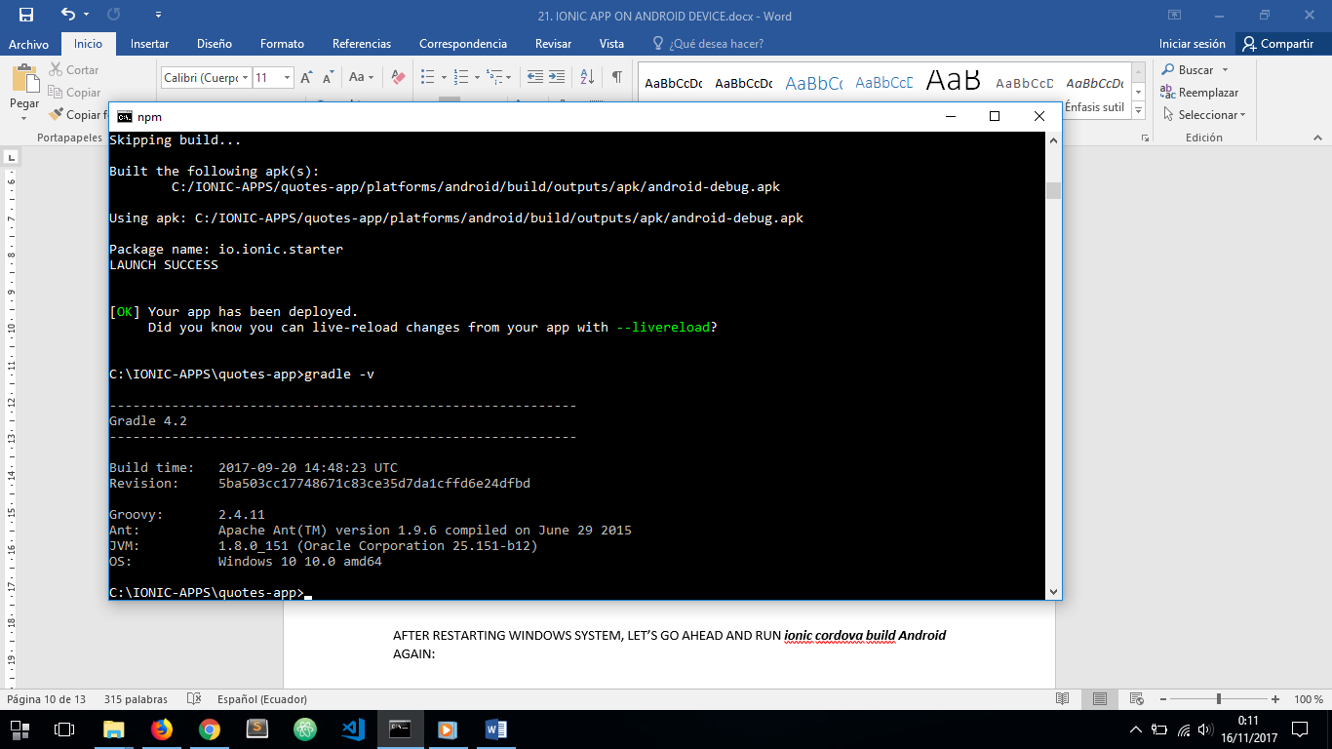

1. NOW WE HAVE GRADLE VERSION 4.2 INSTALLED

AFTER DO THAT, LET’S GO AHEAD AND RUN ***ionic cordova build Android*** AGAIN:

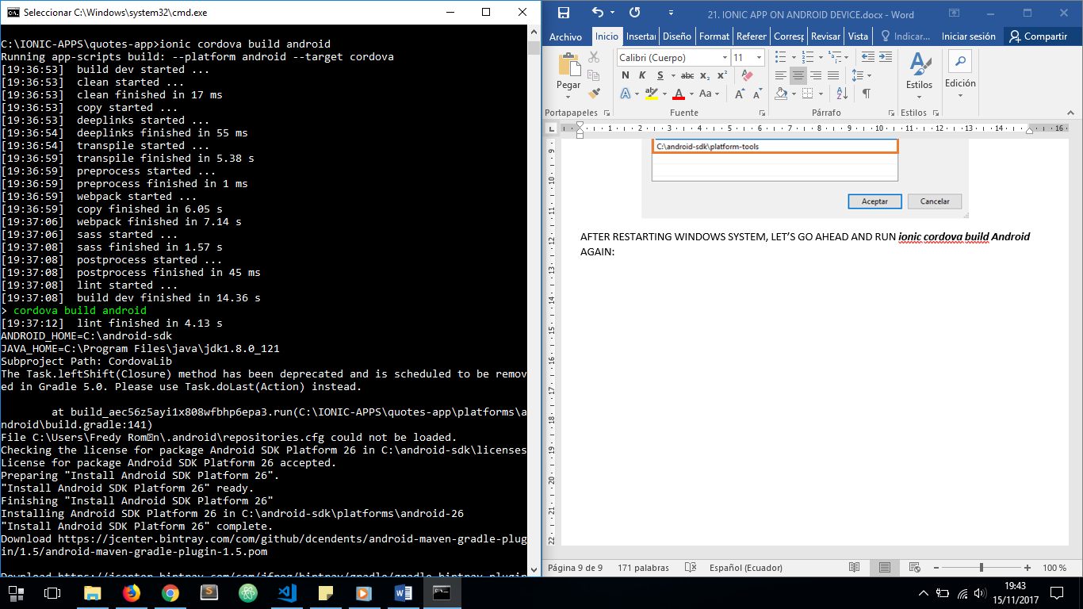

CORDOVA WILL INSTALL ANDROID SDK PLATFORM 26 AUTOMATICALLY:

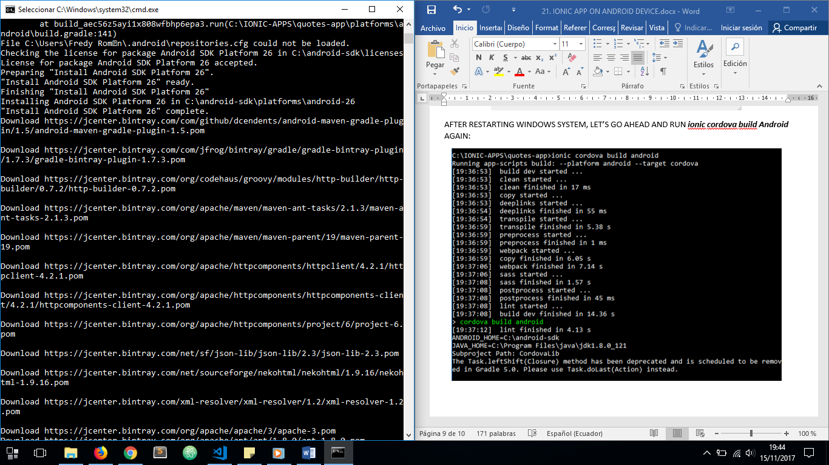

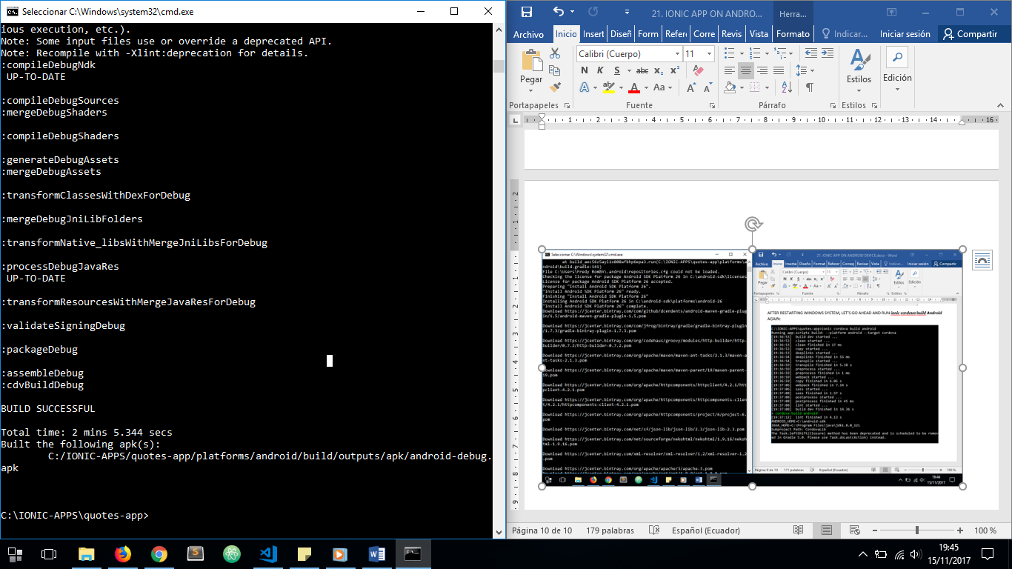

NOW, LET’S RUN OUR IONIC ON AN ANDROID DEVICE CONNECTED TO OUR PC (WE MUST CONFIGURE THE DEVICE WITH DEVELOPER MODE ON AND DEBUG USB ON)

RUN ***ionic cordova run android –device***

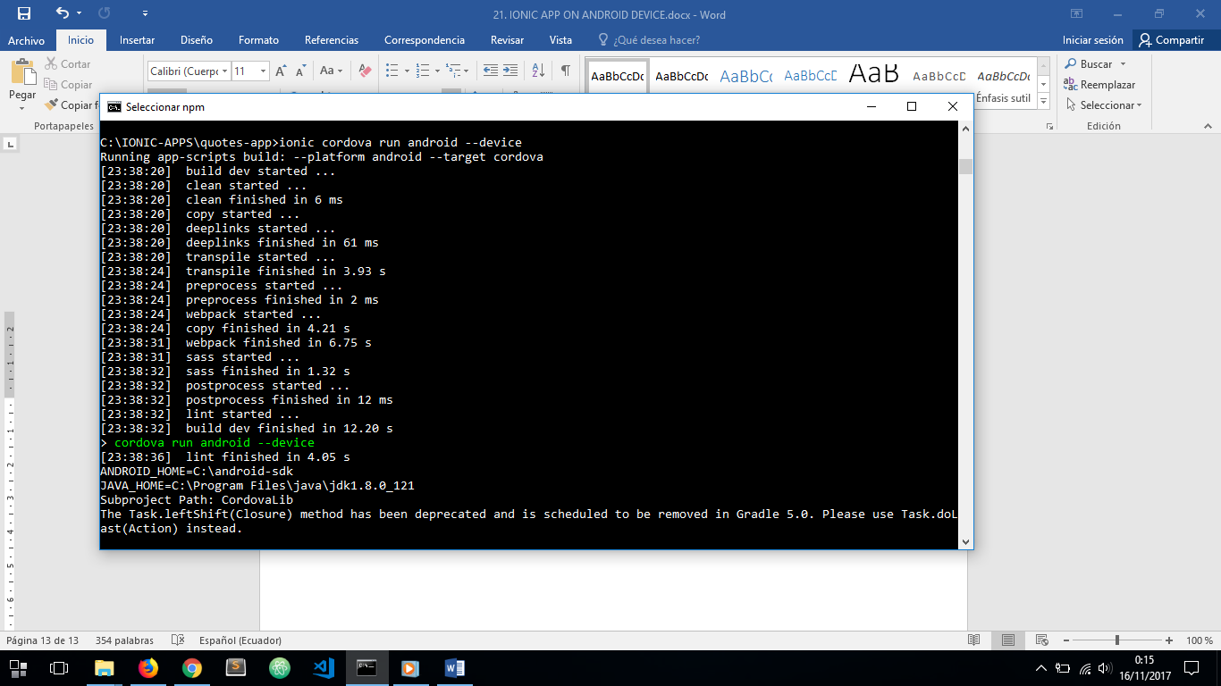

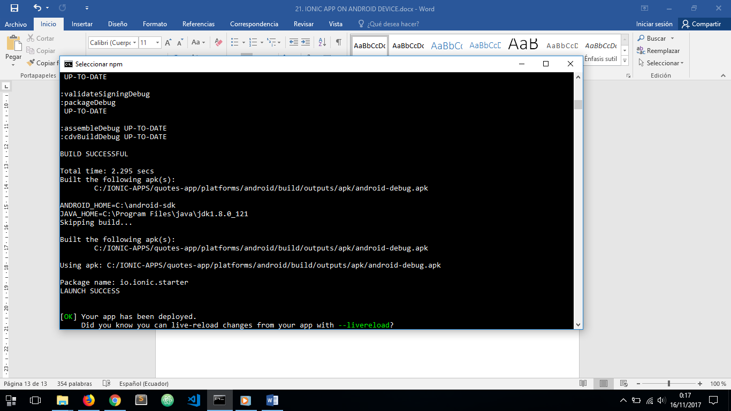

AND AS WE CAN SEE THE PATH TO THE IONIC ANDRIOID APK IS SPECIFIED ON ***platforms/Android/build/outputs/apk/Android-debug.apk***